**Laboratory 7**

**Lab1:**

1. Login into admin application http://localhost:8080

2. Login as

System: PostgreSQL

Server: postgres

Username: demo

Password: demo

Database: shop

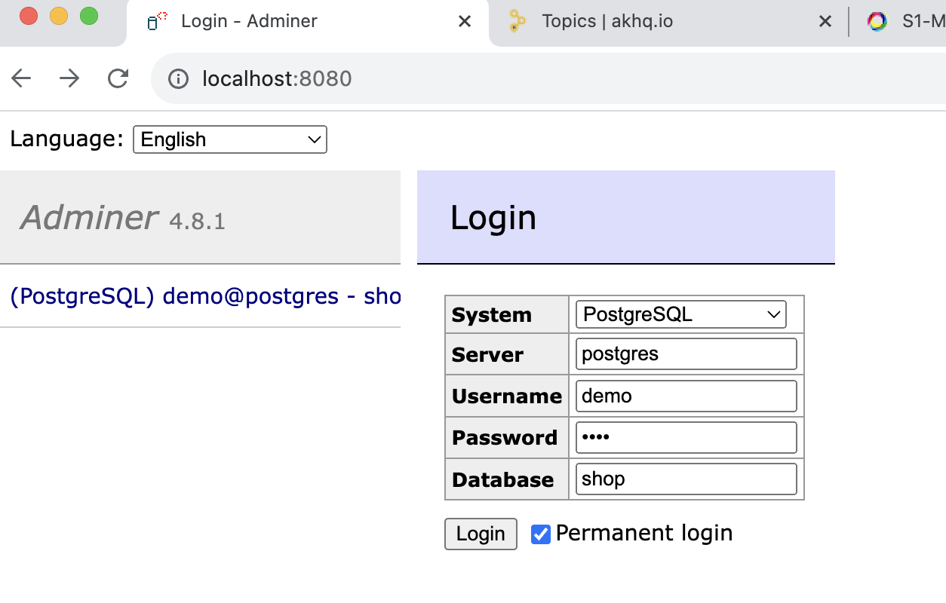

2. Create a database (SQL command)

Press "SQL command" button from left side.

CREATE TABLE IF NOT EXISTS products (

id INT PRIMARY KEY,

name VARCHAR(255),

price INT

);

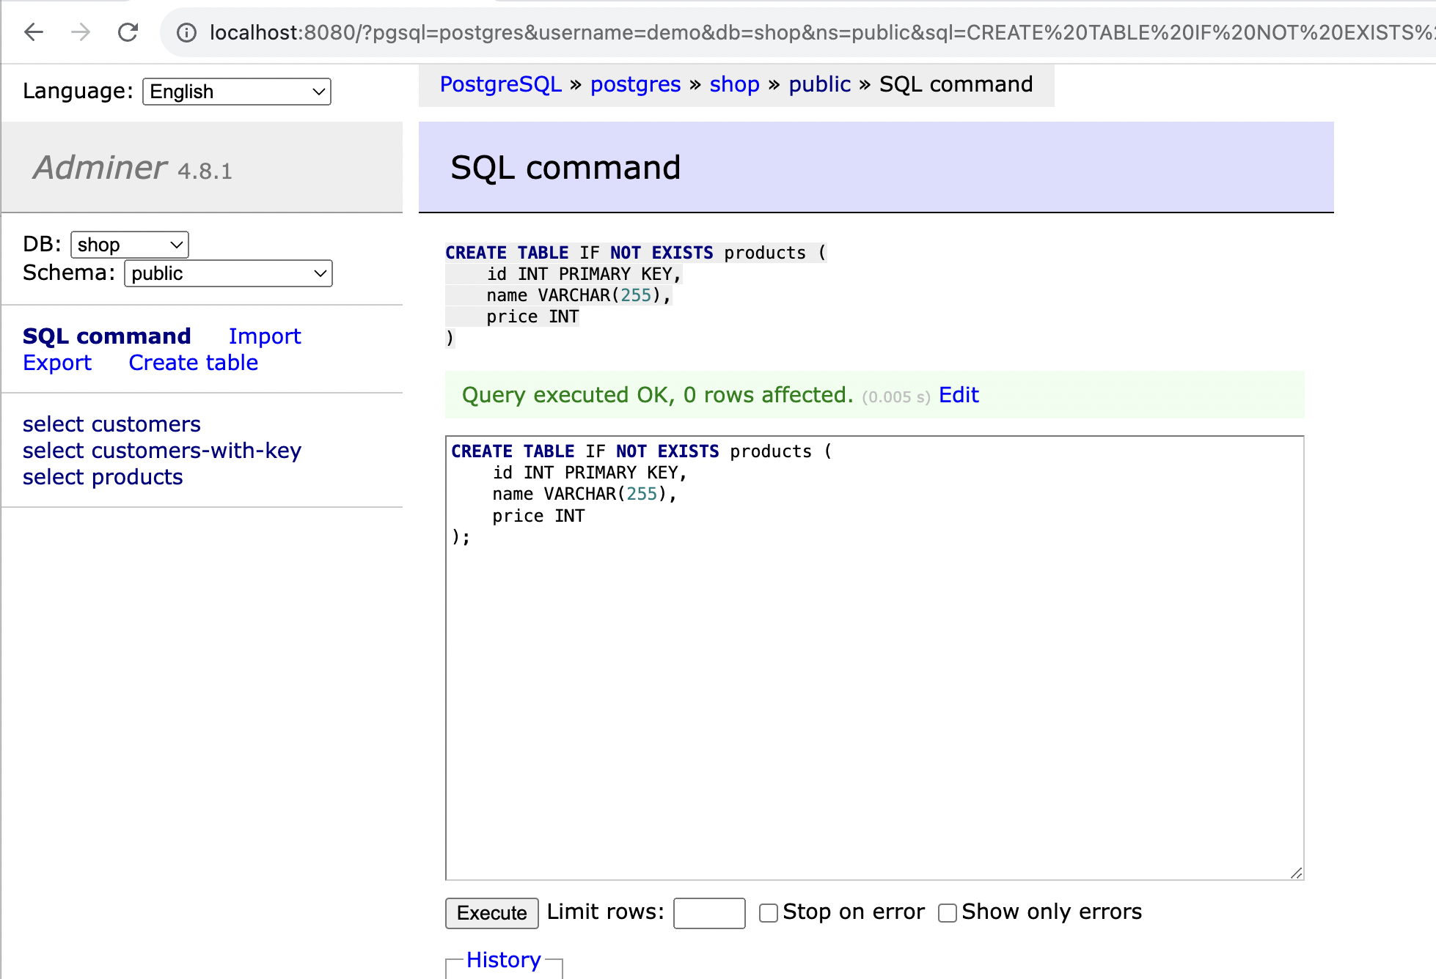

3. Enter SQL Command

insert into products values(1, 'сup', 1);

insert into products values(2, 'kettle', 5);

insert into products values(3, 'phone', 500);

insert into products values(4, 'tablet', 125);

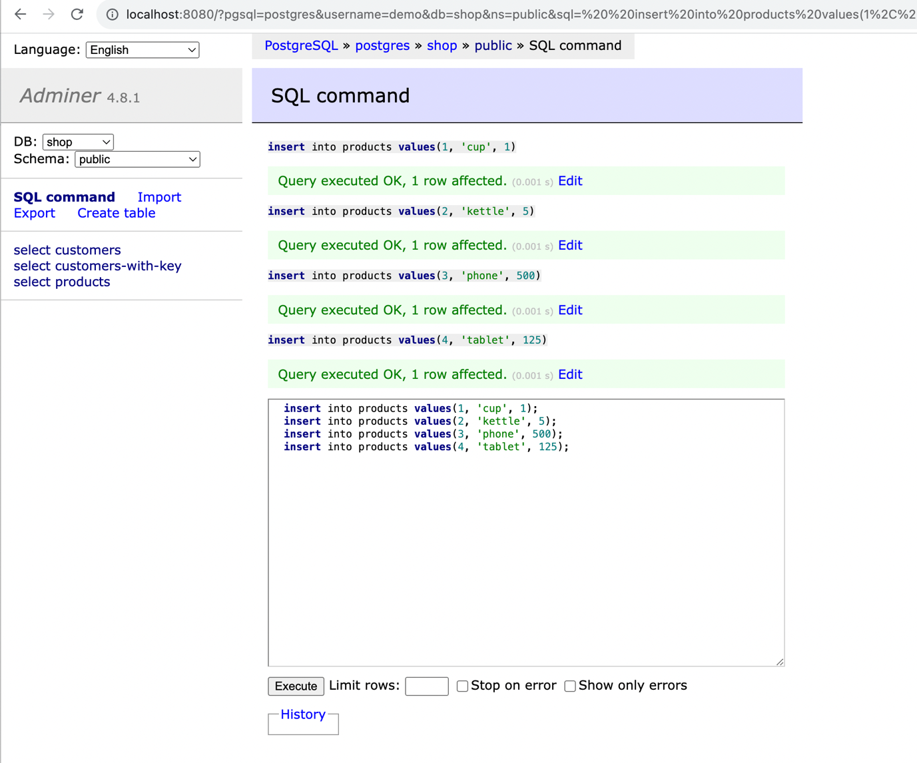

4. Check connector-plugins through control center or through

curl http://localhost:8083/connector-plugins from Windows PowerShell or MacOS shell

or @GET http://localhost:8083/connector-plugins from Postman

5. Add JDBC source connector

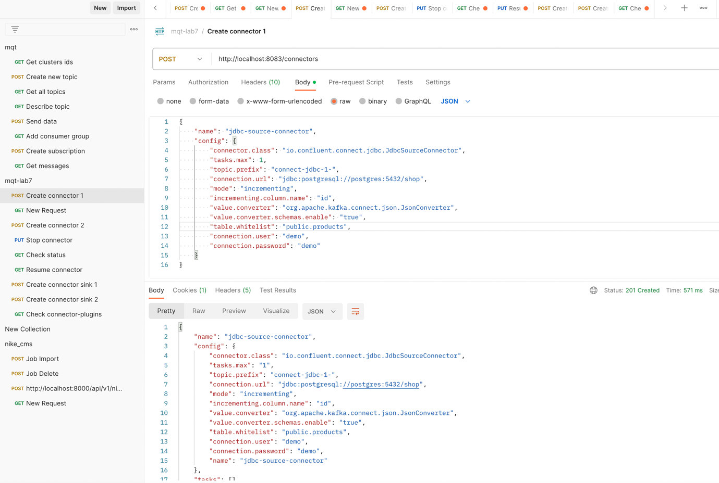

6. Check connectors through Control center or through REST

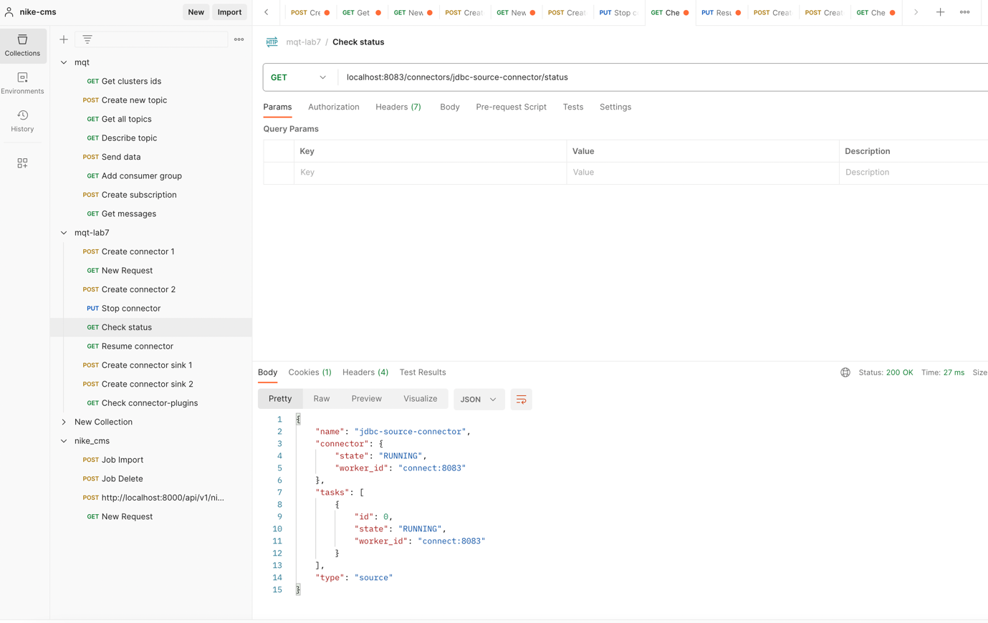

7. Check messages

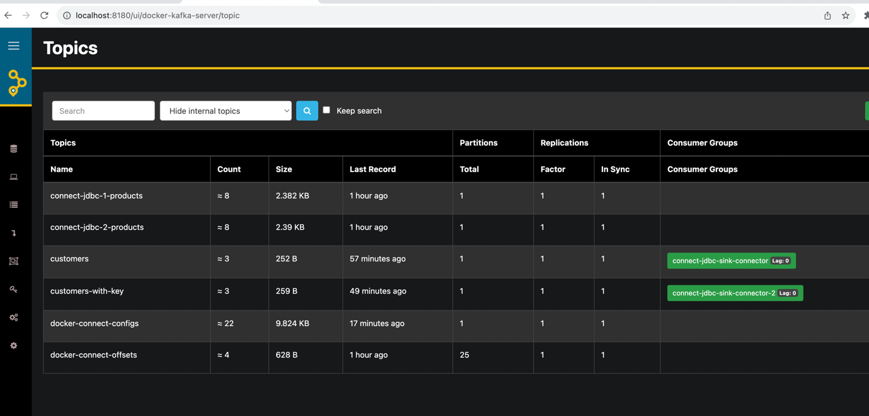

8. Add more data

insert into products values(5, 'toaster', 15);

insert into products values(6, 'coffee maker', 25);

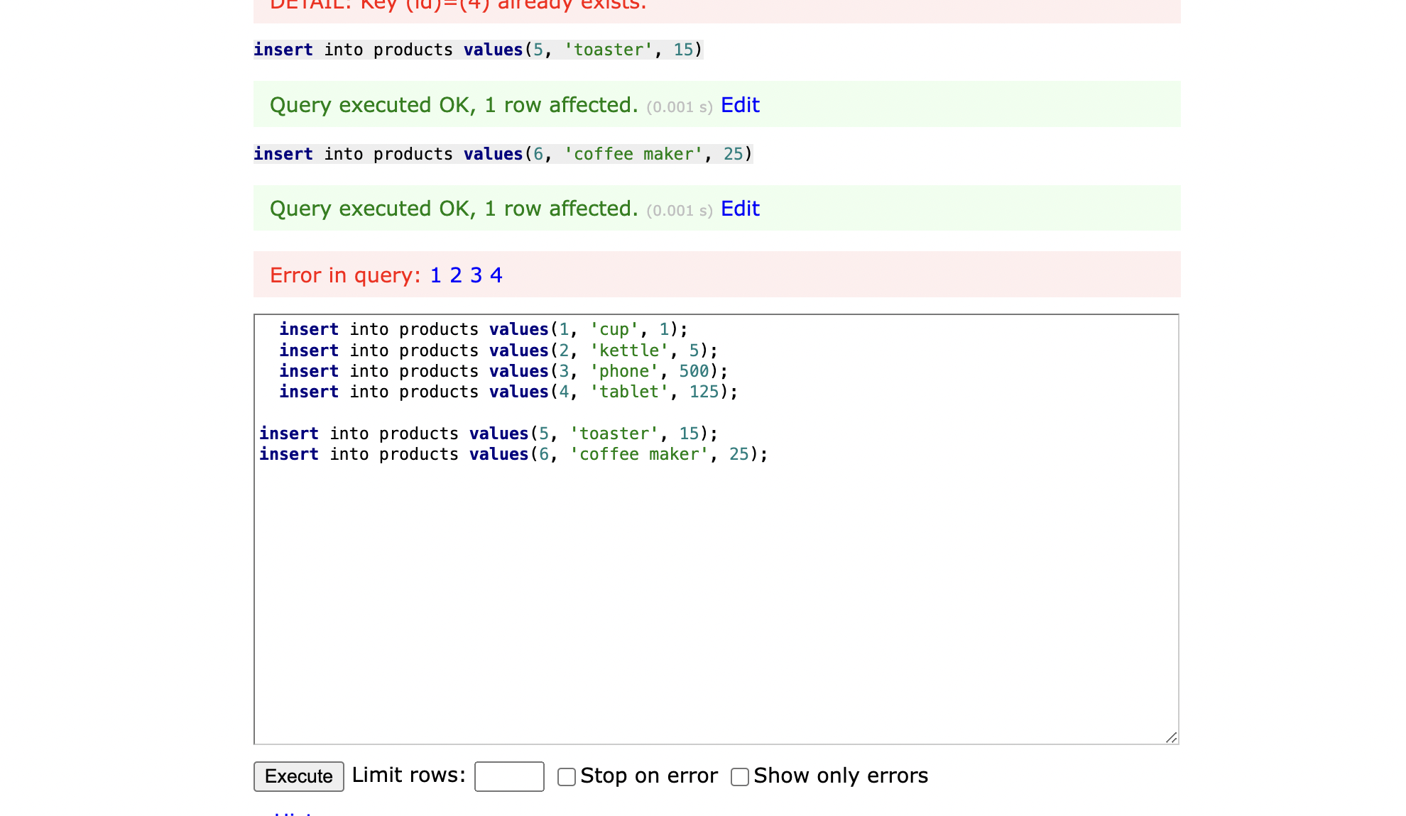

9. Check messages

**Lab2:**

1. Add JDBC source connector

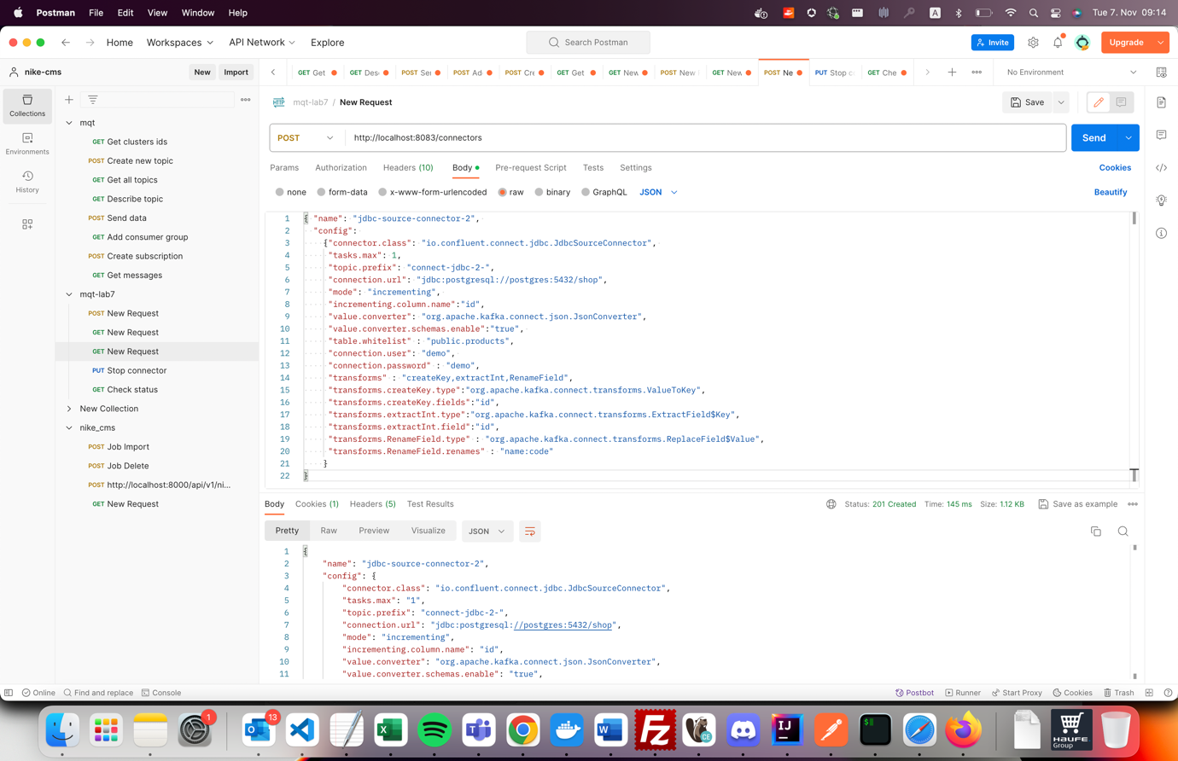

2. Stop connector

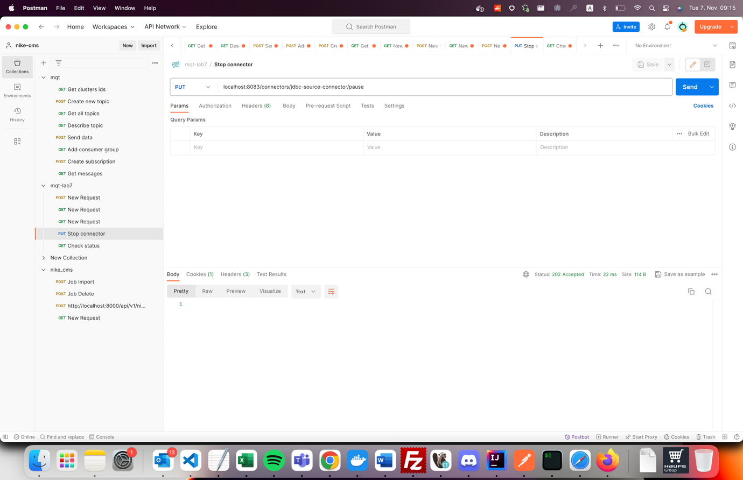

3. Check status

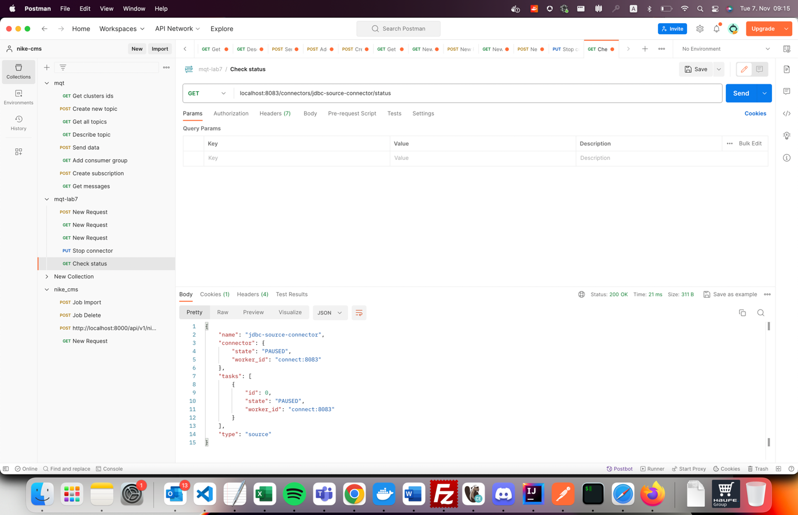

4. Add new data (http://localhost:8080 login as demo|demo, use SQL Command)

insert into products values(7, 'saucepan', 11);

insert into products values(8, 'iron', 7);

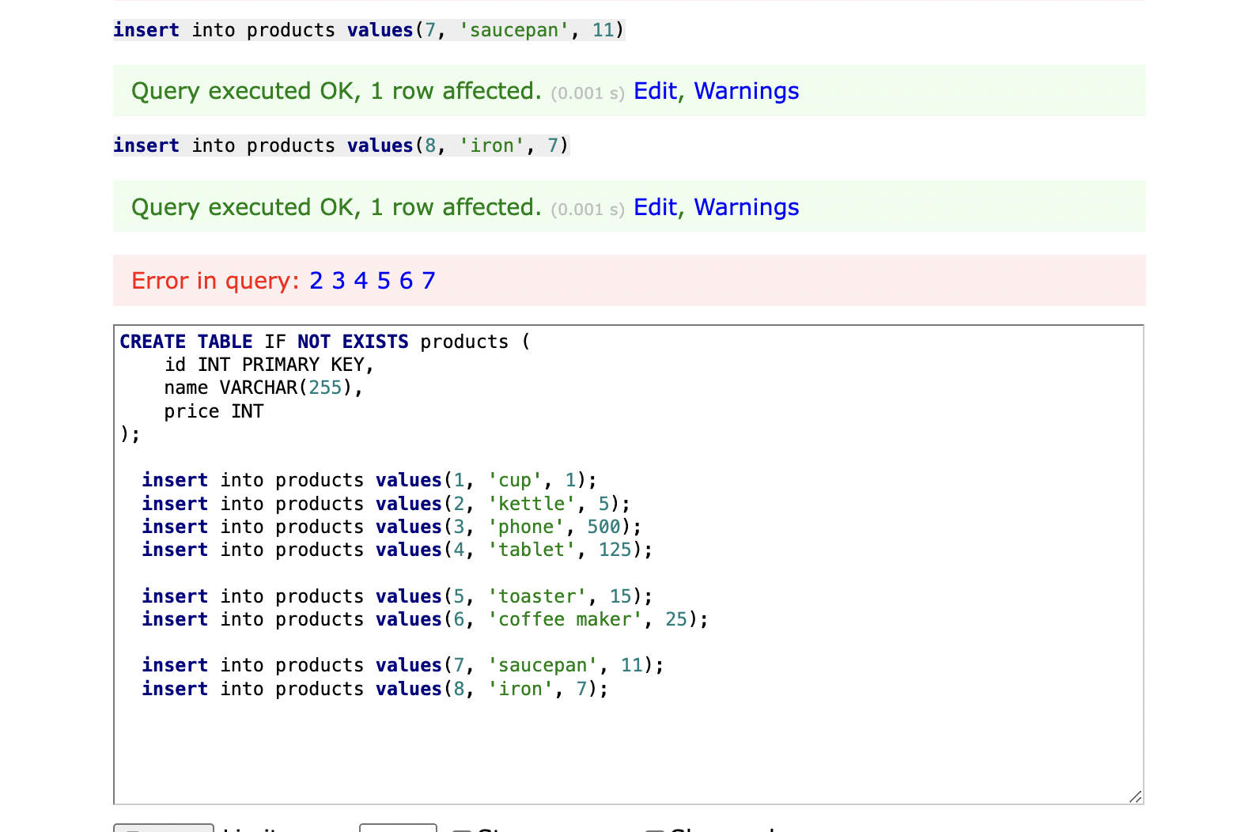

5. Check messages

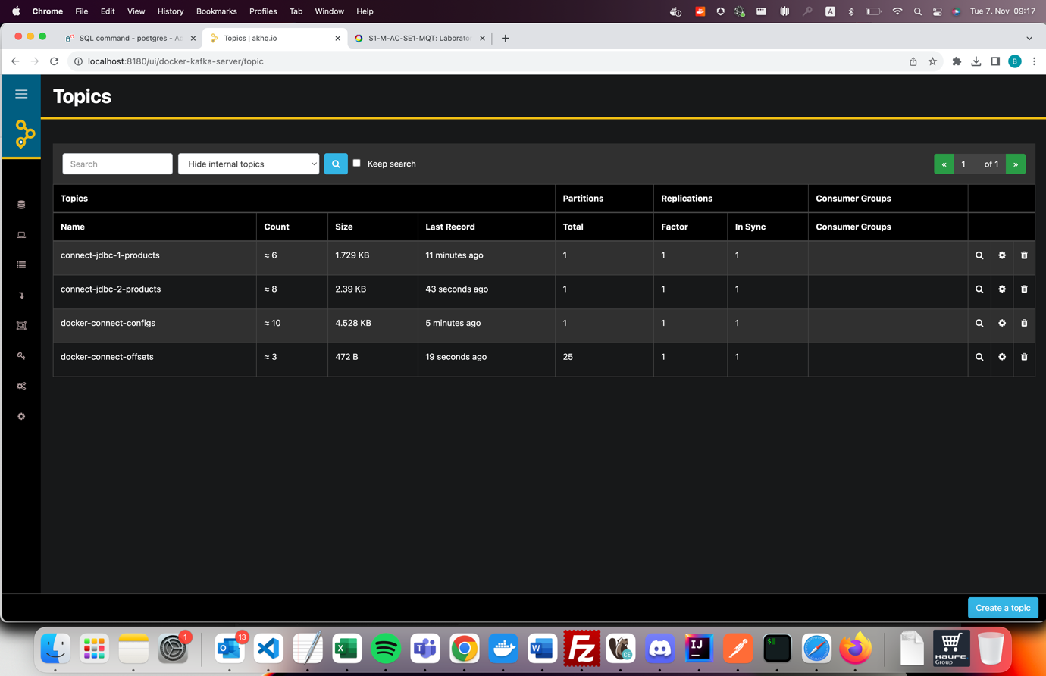

6. Resume connector

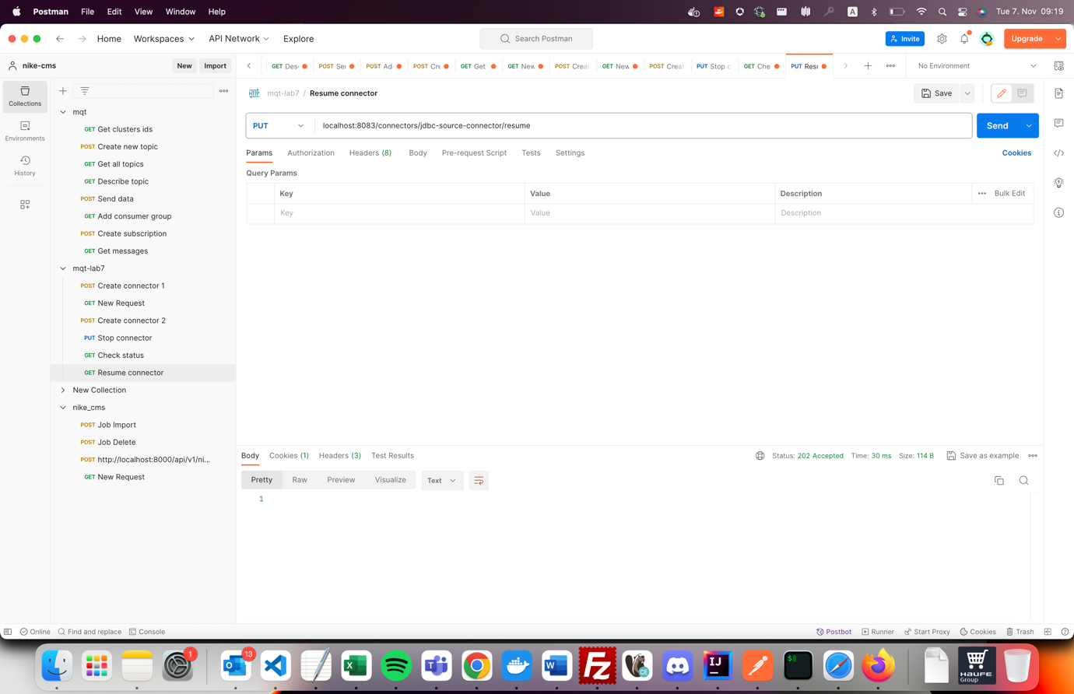

7. Check status

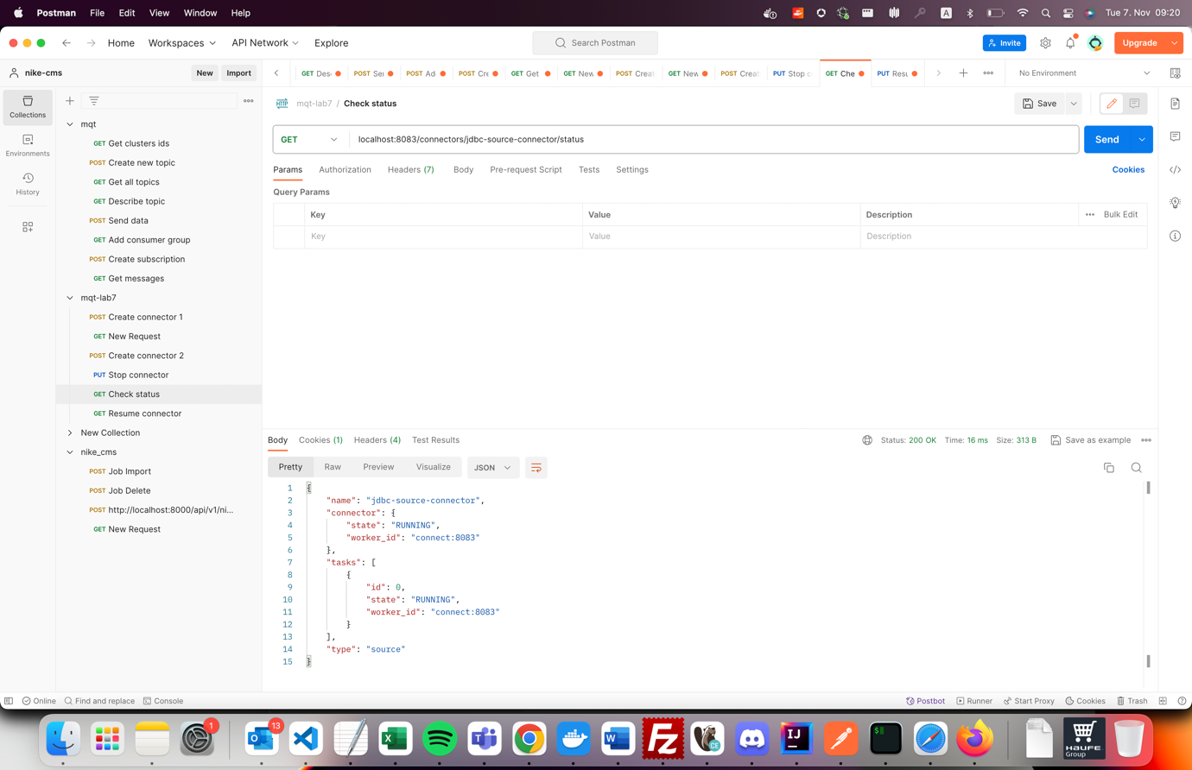

8. Check messages

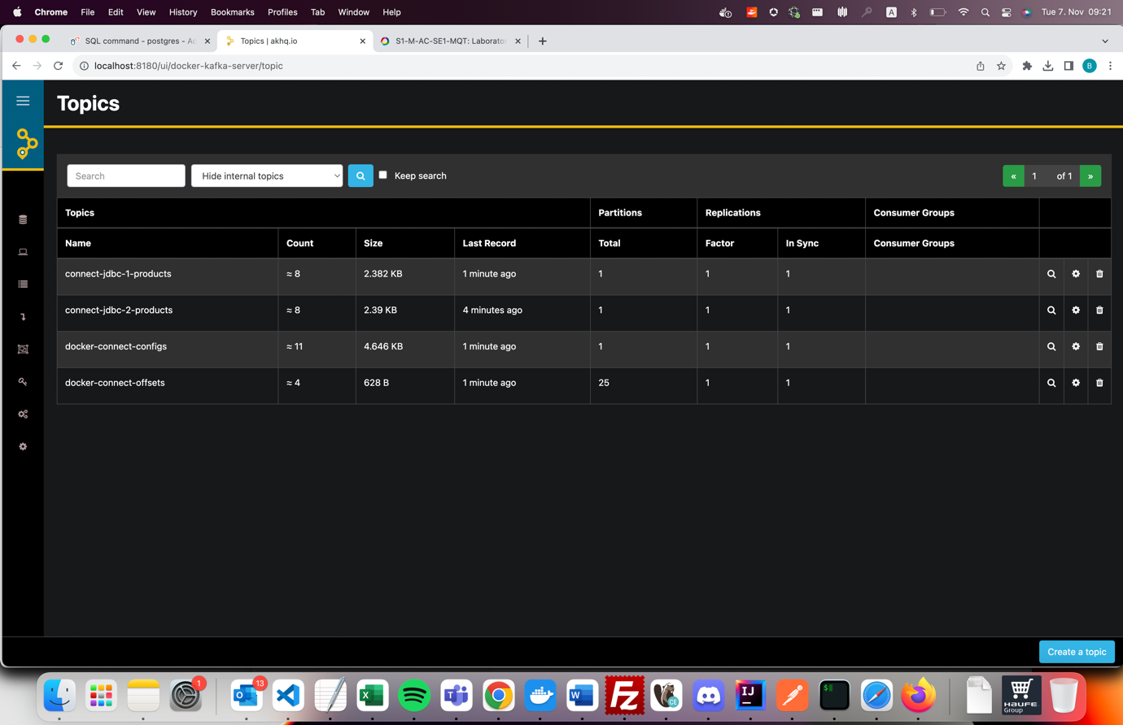

**Lab3:**

1. In Control Center create JDBC sink connector. The configuration is in file postgres-sink-connector-1.json

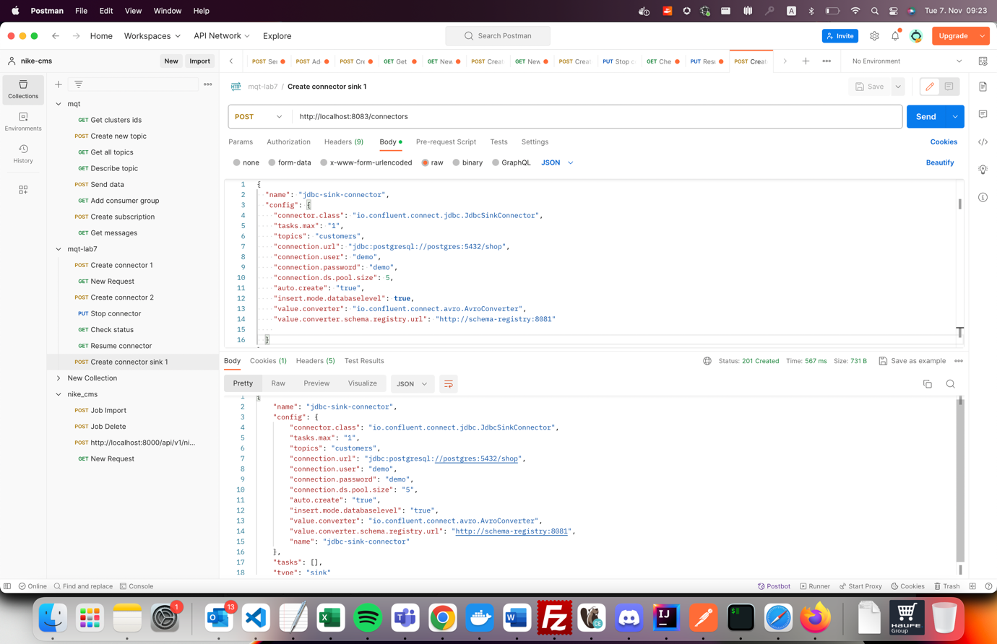

2. In schema registry container produce avro messages

docker exec -ti schema-registry /usr/bin/kafka-avro-console-producer --bootstrap-server kafka:19092 --topic customers --property schema.registry.url=http://schema-registry:8081 --property value.schema="{\"name\":\"lau\",\"type\":\"record\",\"name\":\"customer\",\"fields\":[{\"name\":\"id\",\"type\":\"int\"},{\"name\":\"name\",\"type\":\"string\"}]}"

the command can also be executed from Docker Desktop, schema-registry terminal:

/usr/bin/kafka-avro-console-producer --bootstrap-server kafka:19092 --topic customers2 --property schema.registry.url=http://schema-registry:8081 --property value.schema="{\"name\":\"lau\",\"type\":\"record\",\"name\":\"customer\",\"fields\":[{\"name\":\"id\",\"type\":\"int\"},{\"name\":\"name\",\"type\":\"string\"}]}"

add in the producer console next lines:

{"id": 1, "name": "Jane Doe"}

{"id": 2, "name": "John Smith"}

{"id": 3, "name": "Ann Black"}

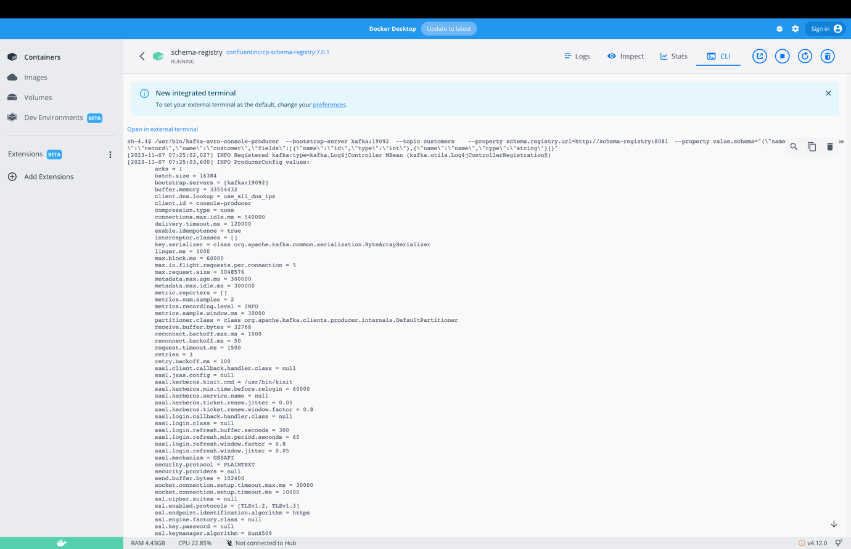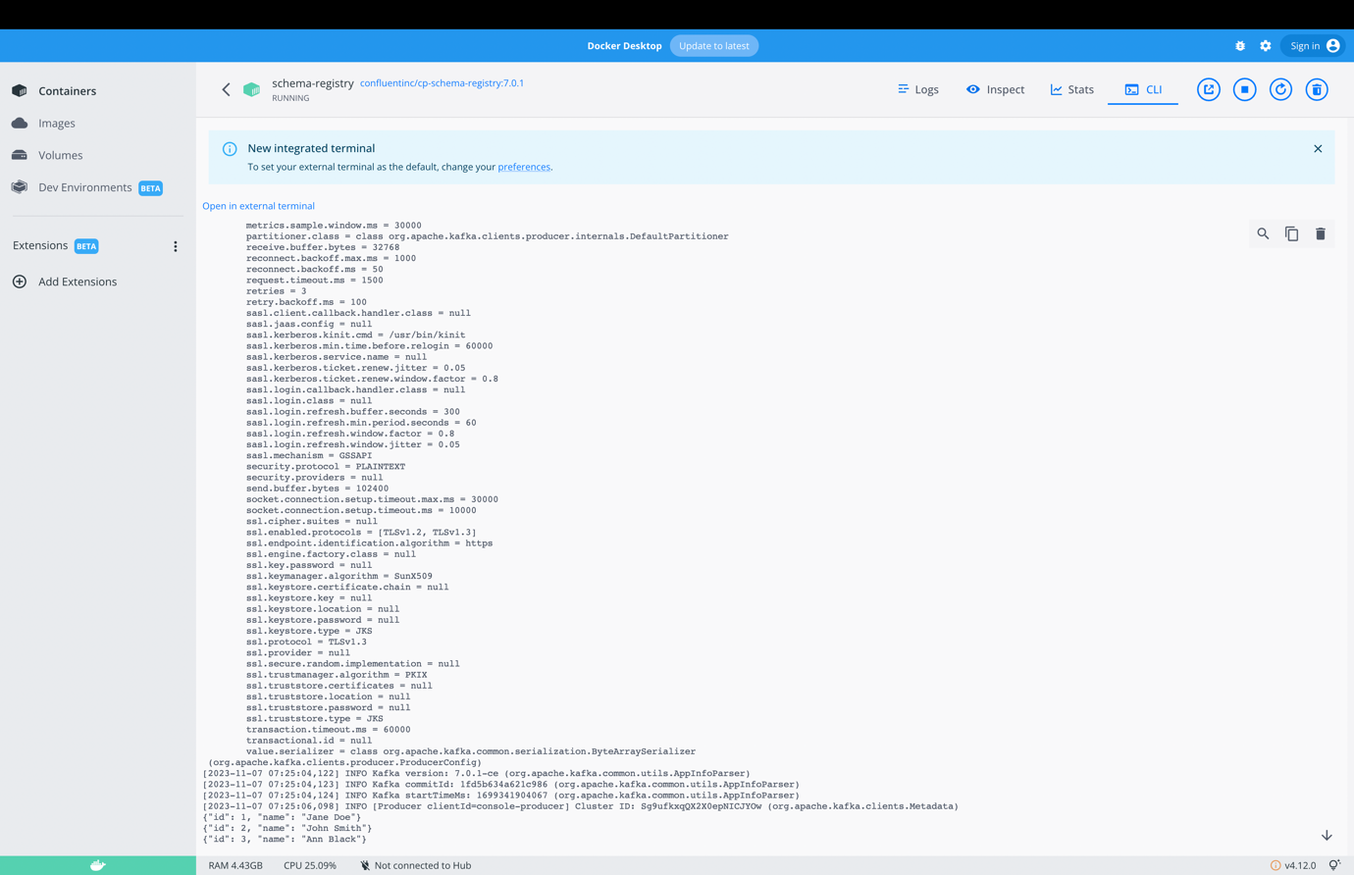

3. Check the table in http://localhost:8080

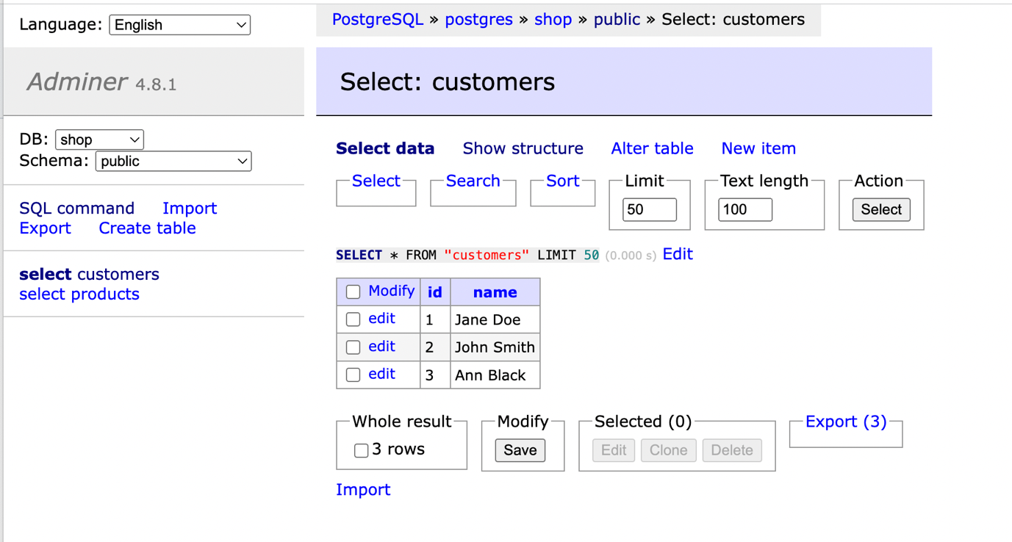

**Lab4:**

1. In Control Center create JDBC sink connector. The configuration is in file postgres-sink-connector-2.json

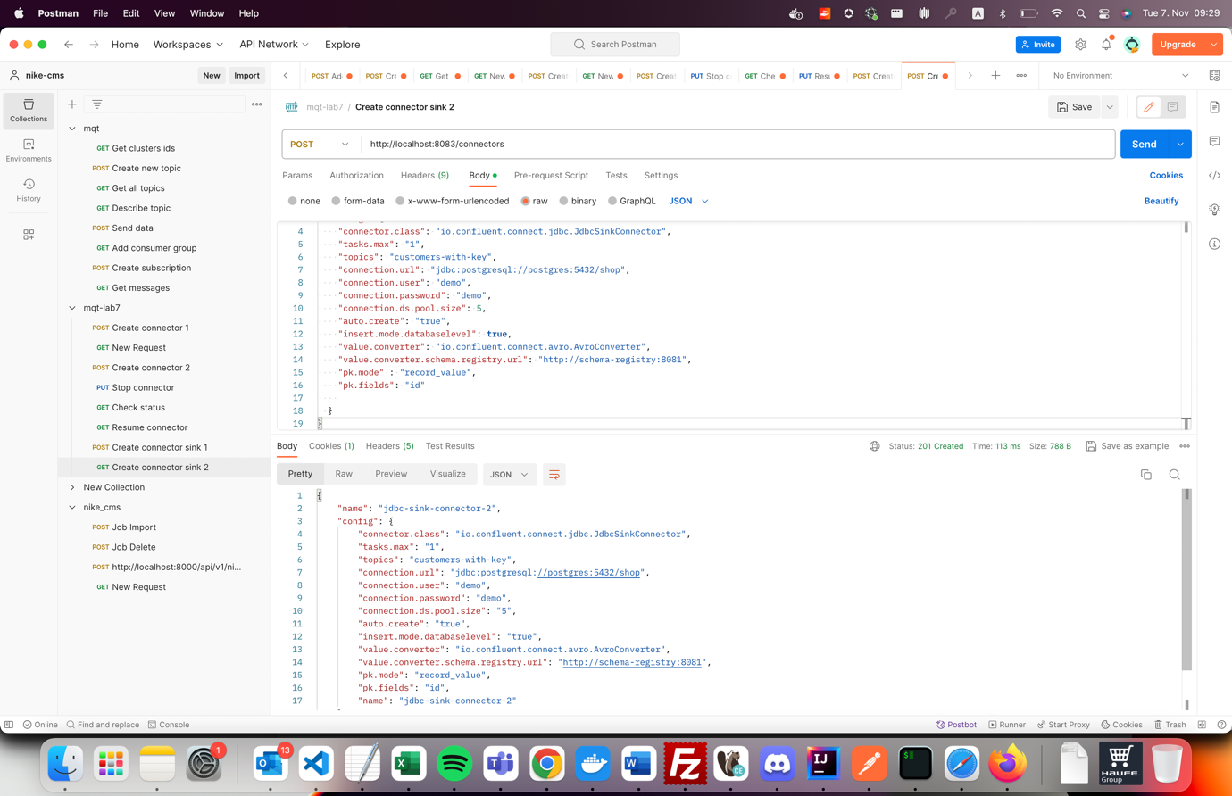

2. In schema registry container produce avro messages

MERGE:

docker exec -ti schema-registry /usr/bin/kafka-avro-console-producer --bootstrap-server kafka:19092 --topic customers-with-key --property schema.registry.url=http://schema-registry:8081 --property value.schema="{\"type\":\"record\",\"name\":\"customer\",\"fields\":[{\"name\":\"id\",\"type\":\"int\"},{\"name\":\"name\",\"type\":\"string\"}]}"

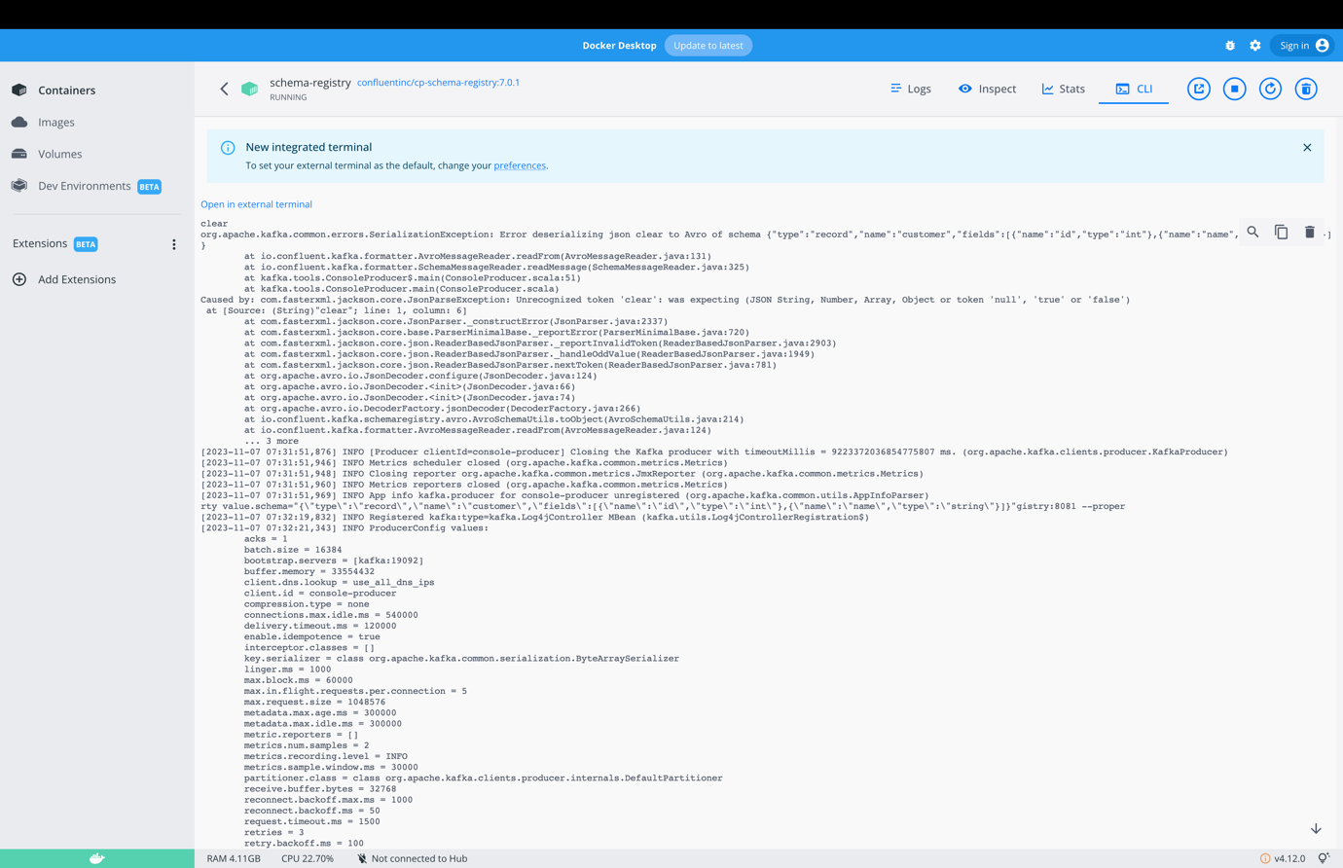

{"id": 1, "name": "Janett Falow"}

{"id": 2, "name": "John Cache"}

{"id": 3, "name": "Black Beauty"}

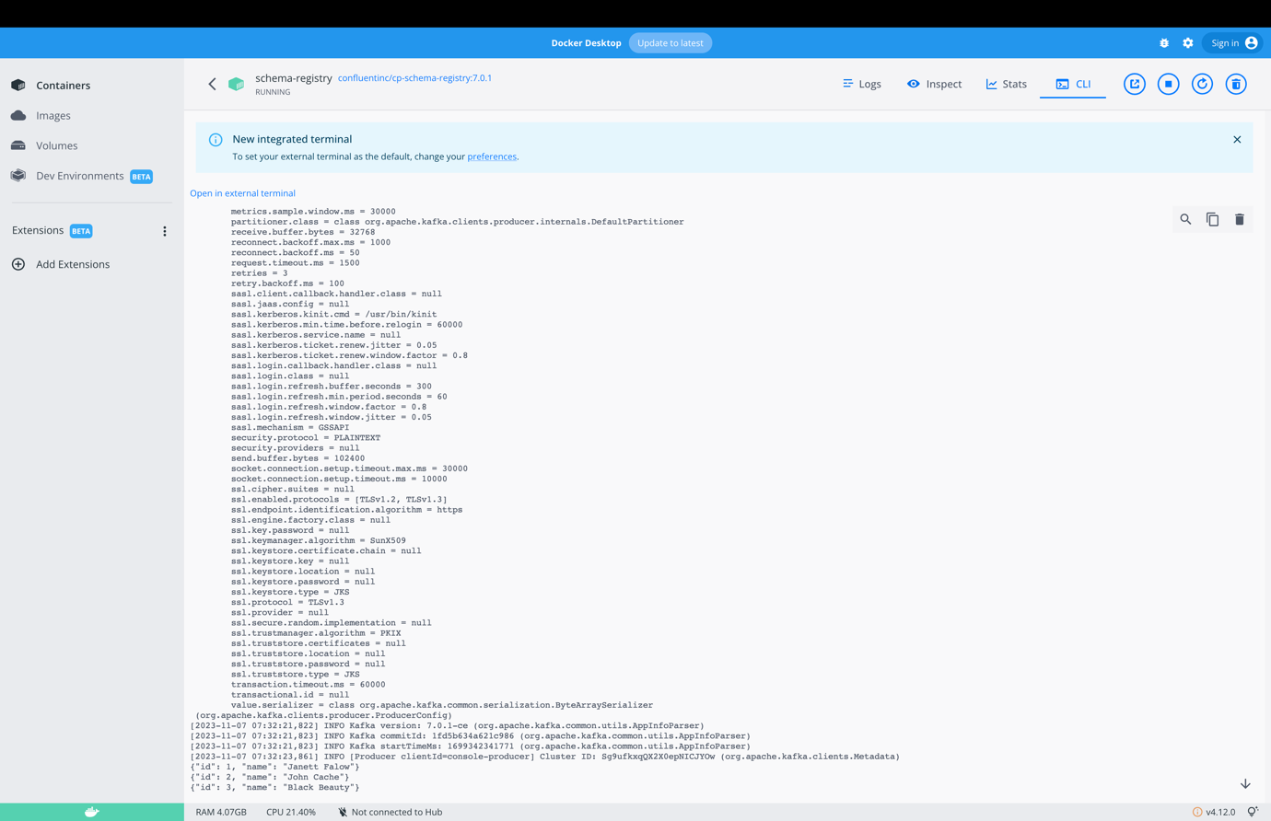

3. Check the table in <http://localhost:8080>

